**HOW TO GENERATE OVERTIME REPORT**

1. Under Reports > Generate Reports select OT Reports and click Generate button.

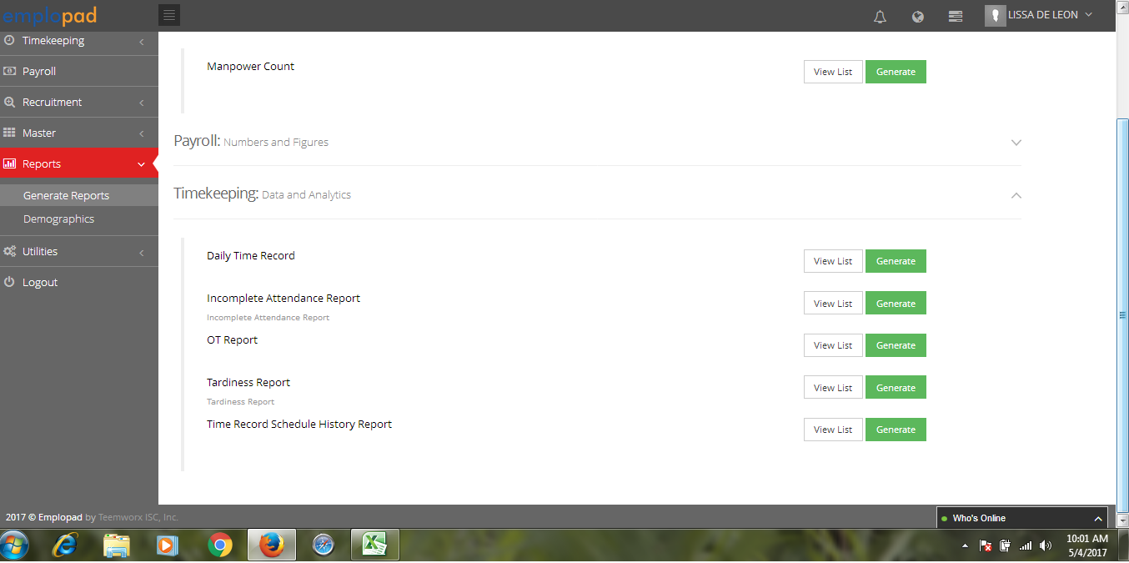

1. Select Company, Set the Payroll Date then click CSV or PDF button.

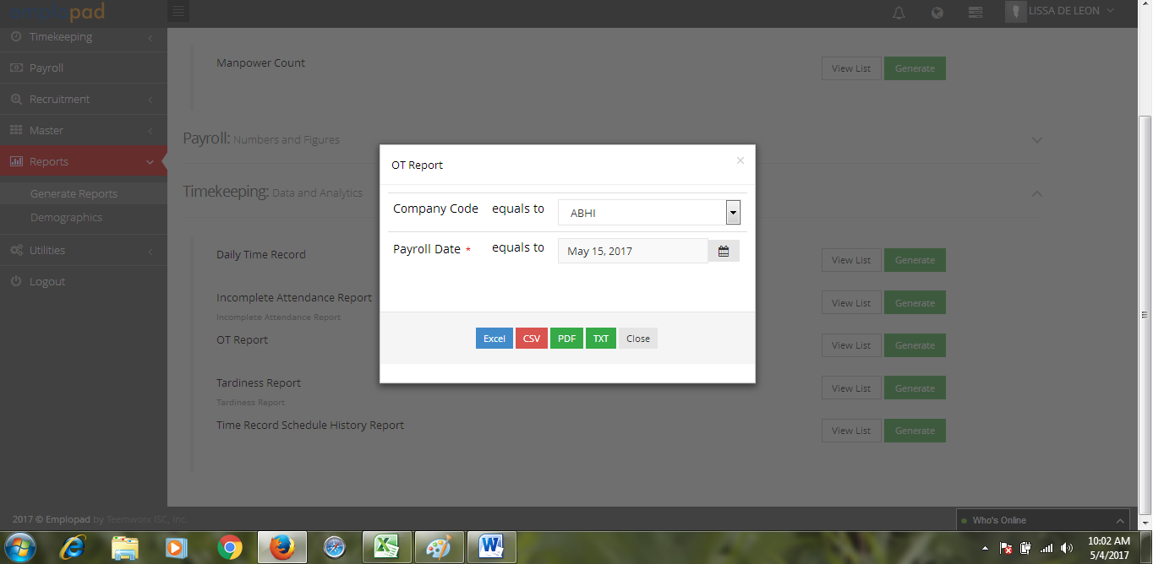

Note: Payroll Date May 15 will generate all the approved overtime from April 1 to April 30.

1. Click OK button.

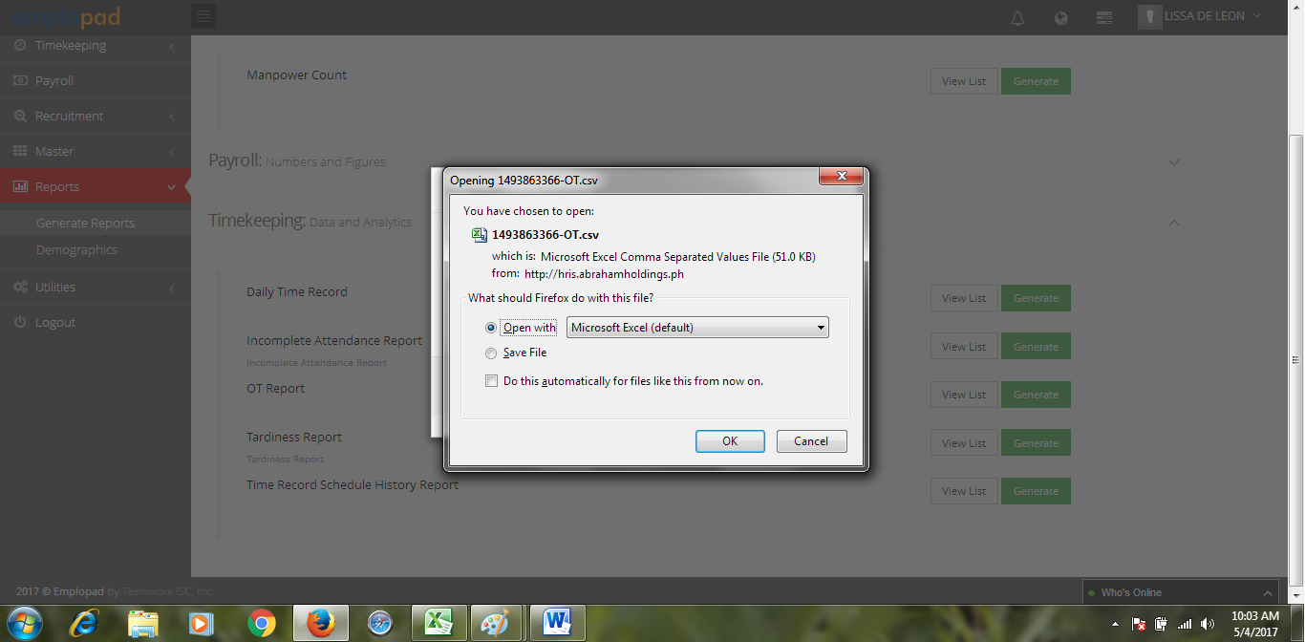

1. Sample OT Reports in CSV format.

